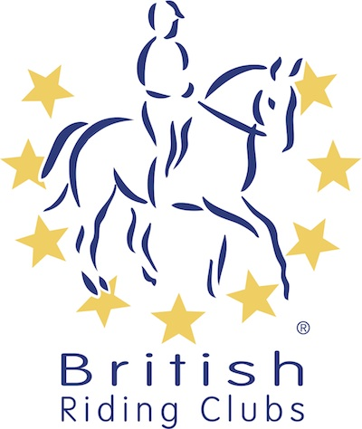
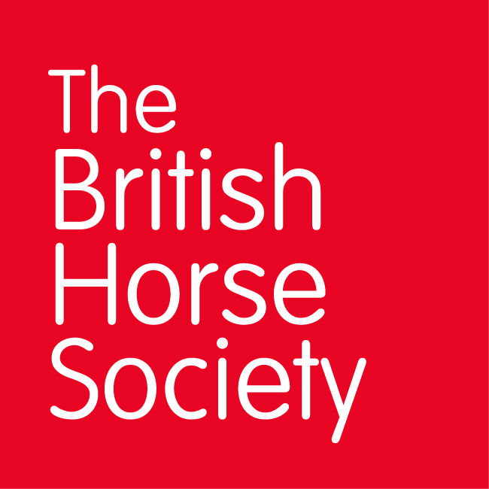
BRC CHAMPIONSHIPS 2022
AREA 16 SUMMER QUALIFIER DATES

COMPETITION | DATE | VENUE | ORGANISER | Official  Steward
Horse Trials | 2nd May  2022 | Epworth EC,  Scawcett Lane,  Epworth,  Doncaster Sth Yorkshire,  DN9 1LQ | Cath Cox (EMDG)  Email: coxy1956@hotmail.com  Mobile: 07801 548216 | Jan Pollard
Show Jumping & Style Jumping | 10th July  2022 | Arena UK, Allington, Grantham NG32 2EF | Vicky O’Gram (Howden RC)  Email: jandv.ogram@sky.com  Mobile: 07767 640580. | Cath Cox
DTM | 11th June  2022 | Hill House Equestrian,  Sand Lane, Osgodby  Market Rasen, Lincs  LN8 3TE | Claire Atkins (RLRC)  Email: claireatkins10@hotmail.com  Mobile: 07801 105419 | Roy Turner  Les Hubbard
Intro Dressage | 11th June  2022 | Hill House Equestrian,  Sand Lane, Osgodby,  Market Rasen, Lincs  LN8 3TE | Claire Atkins (RLRC  Email: claireatkins10@hotmail.com  Mobile: 07801 105419 | Roy Turner  Les Hubbard
Dressage & Riding Test | 9th July  2022 | Arena UK, Allington, Grantham NG32 2EF | Carol Morgan (Tickhill RC)  Email: info@tickhillridingclub.org  Mobile: 07590728217 | Les Hubbard  Roy Turner
Closing dates for all qualifiers are 21 days before the event.
Please note qualifiers should be held at least 28 days before the Championship date.

